PAD FUNCTIONS:

- 1A
- 1Y
- 2A
- 2Y
- 3A
- 3Y
- GND
- 4Y
- 4A
- 5Y
- 5A
- 6Y
- 6A
- VCC

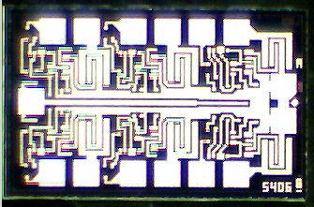

Topside Metal:
Backside Metal:
Backside Potential:
Bond Pad Size: .004” x .004” min
Mask Ref:
APPROVED BY: MG DIE SIZE: 38 X 62 Mils DATE: 3/9/16
MFG: National THICKNESS: P/N: 5406
DG 10.1.2

Rev A 3-4-99

